s Report
dfsdfsdff

Group name
First Airbenders
Project name
COMFORT HOME
Table of Contents
- introduction 2
- project Background
- Project Statement 3
- Process and Results 4
- Conclusion & recommendations 6
- Evaluation / reflection 6

Introduction

Since the people who occupied this world are the most beneficiaries of the new technology that develops daily depending on needs of the people, in other word, how this technology will make the life easier in terms of all fields of the life. The ventilation system is one of these new technologies, it take care of healthy and comfortable air inside the house and the occupants of this house. Ventilation system guaranty somehow fresh, healthy and indoor quality in the home.
It is important to keep air flowing through the home, eliminating contaminants ,odors, control the humidity, and CO2 levels.
This product aims to achieve all the above with high quality in both the service and performance.
the product works fully automatic using components that works remotely with ventilation box, these components consist of temperature and humidity sensor, CO2 sensor, VOC sensor.
All data that collected from the sensors will be processed and showed on the screen of the ventilation box as graph and numbers, also they will be recorded in log file and showed as table in order to let the user look to the history of the readings, in this way the user can compare between months or days how the air quality change.
the readings from every sensor are colored depending on ranges for every type of sensor, red, orange and green.

Project Background
This project aims to provide a ventilation system that works smoothly based on high technology tools, and give in returns high performance and results taking into accounts all possible difficulties.
the system works based on measurements from sensors which are transferred wirelessly to the ventilation box that received these measurements and process them depending on limits for every kind of sensor, then it will either speed up or slow down the fan of the ventilation box.
Since the system needs three kind of sensors temperature and humidity, VOC and CO2, it is also possible to increase the number of the sensors to serve large place if it needs.
Visualizing data is important aspect of the ventilation box to let the user looks to the readings which are comes from the sensor, these data visualize as graph or table.
the product is served by support team in case any technical error in either software or hardware.

Project Statement
the system will be based around the various sensors. Every sensor will measure continuously, but it will send its value every 15 minutes or when a sudden spike in the measures occurs. Those sensors will be connected to a simulated ventilation box in C# on a laptop application, where an algorithm will calculate the state of the air quality and the needed actions to take depending on that state. Additionally, the red LED will also indicate by blinking when the bi-directional communication between a sensor and the app is lost. All the values are sent by the sensors will be stored in a log file where they can be accessed by the user.
Several requirements are important to make sure that the system is integrated from all aspects:

- Performance and scalability
The functionality of the system should works in optimal status with discard how many components connected to the system. The systems must work without interruptions. sending and receiving data through the Wi-Fi network between the sensors will support the idea of connecting many components which means the can be extended smoothly.

- Portability and compatibility
By using the heterogeneity of components ( sensors, actuators, microcontroller,….) interacting, communicating with each other, we should ensure that the system perform without any problem. The system will be able to be compatible with other system component which has not identified, by using a well-structured protocol.
The systems will be functional on every operating system and will not conflict any other applications and processes within the environment.

- Reliability, availability, and maintainability
Since the system is fully automated, also the issues are taken into the account to be solved as much as possible in in automated way, self-healing is a protocol to repot the system and restart all sensors. The issue will sent as report to the support team automatically. We expect the system to work in natural conditions, so if unexpected action occur ( natural disasters ), in this case maintenance team should come to replace the damaged components.

- Usability
The goal of the system to provide a healthy and fresh air by using a completely automated system, depending on the values that come from the sensors, the ventilation box will decide the speed of the fan, on the other hand, in some cases the user wants to control some features like the temperature, so we leave this feature to him to control, through changing the speed of the fan manually.

Process and Results
System architecture:

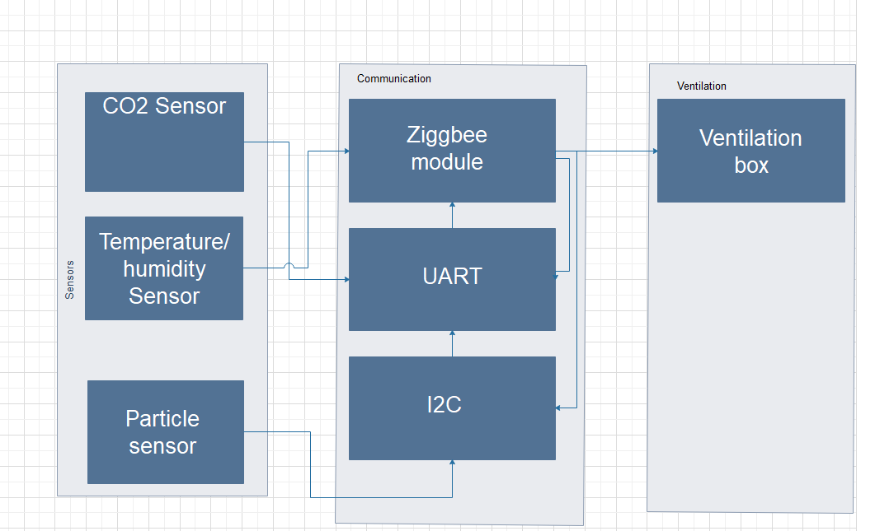
Wiring diagram:
The indoor climate control system consists of several components which interact with each other. The hardware required is as follows:
- STM32 Nucleo-64 development board with STM32F303RE MCU.
- ETRX357 Zigbee module.
- CM1106 CO2 sensor.
- SHT20 temperature and humidity sensor.
- IAQ-Core VOC sensor.
- Optional extensions, i.e. a fan, multiple CO2 sensors or other humidity and temperature sensors.

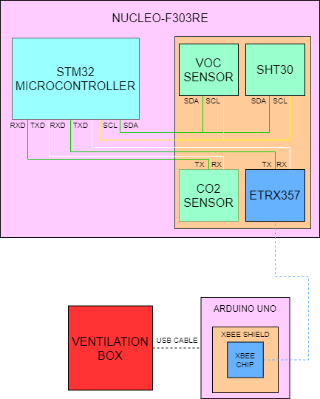

Connection and Protocols:

The embedded board has a couple of sensors connected to it. Each one of them has to communicate with the board through a given communication protocol. They are as follows:
- The temperature and humidity sensor uses I²C.
- The VOC sensor uses I²C.
- The CO2 sensor uses UART.
- The ESP8266 uses HTTP.

The C# application receives data (measured values) from the ESP8266 module. The format in which the data is being sent has thoroughly been discussed with several groups. Sending format of values:

# | TEMP | ; | CO2 | ; | HUMID | ; | VOC | ; | IP | $

The values temp (temperature), CO2 (carbon dioxide), humid (humidity), VOC (volatile organic compounds) and IP (internet protocol address) are formatted together with the start symbol (#), separators (;) and the end symbol ($).

Communication between the C# application and the ESP8266 module takes place every 5 minutes or when a spike is detected from the CO2 or VOC sensor. In that case the values are being sent including a percent symbol (%) in front of the CO2 or VOC value, depending on which sensor detected the spike.

Control flow diagram:

Due to the pandemic the ZigBee module is replaced by ESP8266.

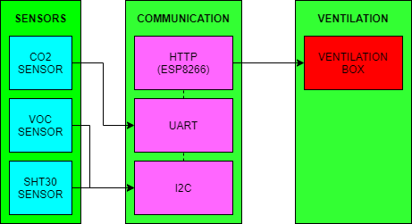

Conclusion and Recommendation
Ventilation system is important for keeping the air quality inside the house fresh, clean and healthy which is hard to achieve these specification using only the natural ventilation.
In light of large number of pollutants, it will be useless to only use natural ventilation, Especially if the house or building located in the center of the city.
So, the ventilation system is effective when:
. the needs of energy for heating or cooling can be reduced.
. the number of occupants of house or building are bigger than the maximum.
. the cities that are located near factories which produce huge of pollutants air.
May the natural ventilation still cheaper than the this ventilation system, but since this product provide an accurate results with high performance, it still more efficient than natural ventilation.

Evaluation and Reflection
Working as team within this project in these pandemic was somehow challenge, because most of the work was remotely, but as a team we were able beat all circumstances.
This project was interesting in terms of working for the first time with real company (Airios) and they provide all clarification that we need to finish this project.

